Land a bonus with these big Slots
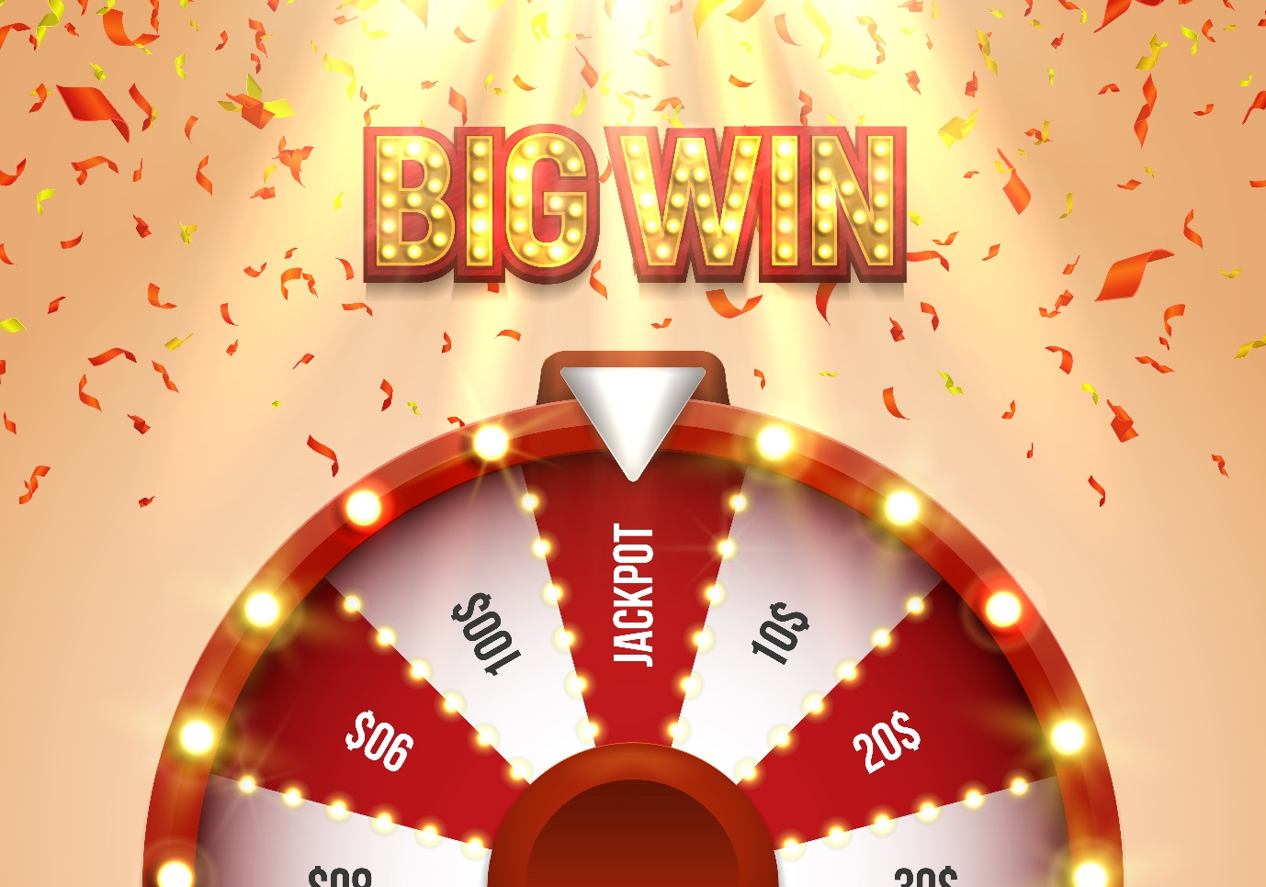
As far as online gaming is concerned, there’s nothing quite like playing Slots. You may have memories of those large, loud machines in the corner of your local, but they’ve certainly come a long way since then. From classic and retro-inspired games, to innovative titles and the latest games with lucrative bonuses and progressive jackpots – there’s something for everyone. No matter what your budget is, or your interests are, online casino games take you on a real voyage of discovery. And if you’re looking for some big games to get the ball rolling – or should that be, the reels spinning – read on, as we give our top picks.
Big Bass Bonanza
Are you angling for a win? You need to check out this five-by-three slot, which may have just 10 pay-lines, but could see you land up to 250x your wager. Play starts from 0.10 credits, making it suitable for all budgets and this game is all about the symbols.
In Big Bass Bonanza, there are no fewer than 12 symbols, which range from the low-value high-card symbols (10 through to A), to the bass symbol, tackle box, fishing rod and buoy. Next up, we have the wild, in this case, the fisherman, who will appear on the reels at any time, and substitute symbols to form more winning combinations. The scatter is another bass, this time, caught – and you need three or more to unlock to the free spins feature.
During free spins, the fisherman collects or adds fish symbols to the reels, as well as increases the multiplier to land more lucrative wins. The multiplier can rise to 10x, and unlocks the dynamite feature. Here, random symbols transform into fish symbols to once again help form bigger wins.
Can you rise to the bait?
Big Bonus
If you’re into classic gaming, you’ll love this retro-inspired slot – inspired by the machines of yesteryear. Big Bonus is played out on a six-by-four interface, providing up to 50 ways to win and play starts from the small sum of 0.10 credits.
The slot will give you all the nostalgic feels, as watermelons, cherries, grapes and lemons will appear on the reels – as the lower-value symbols. While the lucky 7s are exactly that, providing the more substantial wins. And while this might be a retro game, there are still wilds and scatters which appear at different stages of the game. The wild appears on all reels during the base game, and during free spins, won’t appear on the first reel.
It’s the scatter you want to land on the reels though, and three will activate the Big Bonus Win Value feature. Once unlocked, bonus symbols will transform into multipliers – awarding you up to 100x your bet.
Big Top Tombola
Join the fun of the fair, with Big Top Tombola – a five-reel, 20 pay-line slot, which could see you play for jackpots worth 5,000x your initial wager. Set within a circus big top, you won’t want to clown around if you have eyes on the prize – a progressive jackpot and a Golden Ticket bonus game.
Expect fun and frolics with symbols including a dancing elephant, clown, lion and ringmaster – which are among the highest. The game’s wild is the big top, which as Slots’ fans have come to expect, substitutes symbols to form more winning combinations. The golden ticket is the scatter which can then unlock the in-game bonus. Play the big wheel bonus, and receive a raffle ticket which will display your multiplier bonus. The more pay-lines you play, the more likely you’ll land a golden ticket.
You’ve got to be in it to win it!

